**ADDITIONAL EXERCISE**

**TITLE:**

Write a program to declare two integer and one float variables then initialize them to 10, 15, and 12.6. Also print the variable values in the screen.

**Objective:**

* To know different types of data types,
* To be familier with printf function.

**Problem analysis:**

Based on given problem, our program must initialize two integer variable to 10 and 15 and one float variable to 12.6.

The given program should display above initialize variable.

|  |  |
| --- | --- |
| **Input variables** | **Necessary header files/functions/macros** |
| in1,in2(int type)  f1(float type) | stdio.h  coino.h  printf() |

**Algorithm:**

1. Start
2. Define variable: in1=10, in2=15, f1=12.6
3. Display in1, in2, f2
4. Stop

**Flowchart:**

Start

End

1. Display in1, in2, f2
2. Define variable: in1=10, in2=15, f1=12.6

**Code:**

#include<stdio.h>

#include<conio.h>

int main()

{

Clrscr();

int in1=10,in2=15;

float f1=12.6;

printf("The initilize integer variable are:\t%d\t%d\n",in1,in2);

printf("The initilize float variable is:\t%f",f1);

getch();

}

**Output (Compilation, Debugging and Testing):**

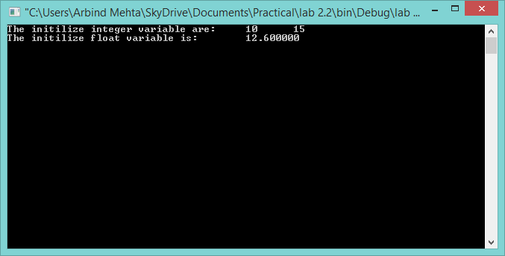

**Discussion & Conclusion:**

In this lab of C programming, based on the focused objective(s) to understand about C data types and printf function.

**Title:**

Write a C program to prompt the user to input 3 integer values and print these values in forward and reversed order.

**Objective:**

* To be familiar with different argument of printf() and scanf() function.

**Problem Analysis:**

Based on problem, it is required to get the input of three integer value and display them in forward and reverse order.

|  |  |
| --- | --- |
| **Input variables** | **Necessary header files/functions/macros** |
| in1, in2, in3(int type) | stdio.h  coino.h  scanf()  printf() |

**Algorithm:**

1. Start
2. Define variables: n1, n2, n3
3. Take input from keyboard for all the input variables
4. Display the in1, in2, in2
5. Stop

**Flowchart:**

Start

Define variable: in1, in2 ,in3

Read in1, in2, in3

Print in1, in2, in3

End

**Code:**

#include<stdio.h>

#include<conio.h>

void main()

{

clrscr();

int n1,n2,n3;

printf("Enter three integer value:\n");

scanf("%d\t%d\t%d",&n1,&n2,&n3);

printf("You have entered:%d\t%d\t%d\n",n1,n2,n3);

printf("And its reverse order is:%d\t%d\t%d",n3,n2,n1);

getch();

}

**Output (Compilation, Debugging and Testing):**

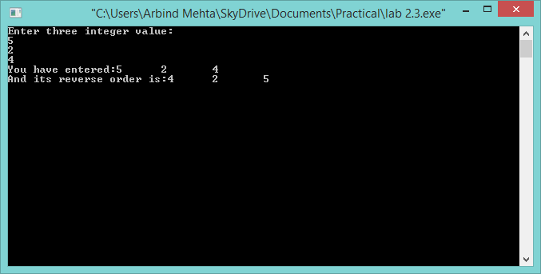

**Discussion & Conclusion:**

In this lab of C programming, based on the focused objective(s) to learn the syntax and argument of printf() and scanf() function.

**Title:**

Write a program to calculate simple and compound interest.

**Objective:**

* To be familiar with different data types, operation and expression in C

**Problem Analysis:**

Based on problem, it is required to find simple and compound interest by taking input of rate, time, principle amount and number of periods. The read float values are then passed into given expression to get simple and compound interest.

Simple interest=((p*t*r)/100);

Compound interest=p((1+r)n-1);

|  |  |  |  |
| --- | --- | --- | --- |
| **Input variables** | **Processing variables/calculations** | **Output variables** | **Necessary header files/functions/macros** |
| p, t, r, n(float type) | x, y(float type) | ci, i(float type) | stdio.h  coino.h  math.h  scanf()  printf() |

**Algorithm:**

1. Start
2. Define variables: p, t, r, n, x, y, ci, I,
3. Take input from keyboard for all the input variables
4. Calculate simple and compound interest :
5. i=((p*t*r)/100);
6. ci=p((1+r)n-1);
7. Display the i, ci
8. Stop

**Flowchart:**

Start

Define variables: p, t, r, n, x, y, ci, I,

Read p, t, r, n, x, y, ci, I,

i=((p*t*r)/100);

ci=p((1+r)n-1);

Print: i, ci

End

**Code:**

#include<stdio.h>

#include<conio.h>

#include<math.h>

void main()

{

clrscr();

float t,r,p,ci,i,x,y,n;

printf("Enter pinciple, time, rate, number of period:\n");

scanf("%f%f%f%f",&p,&t,&r,&n);

i=((p*t*r)/100);

x=pow((1+r),n);

ci=(p*(x-1));

printf("The interest is:%f\n",i);

printf("The compoud interest is:%f",ci);

}

**Output (Compilation, Debugging and Testing):**

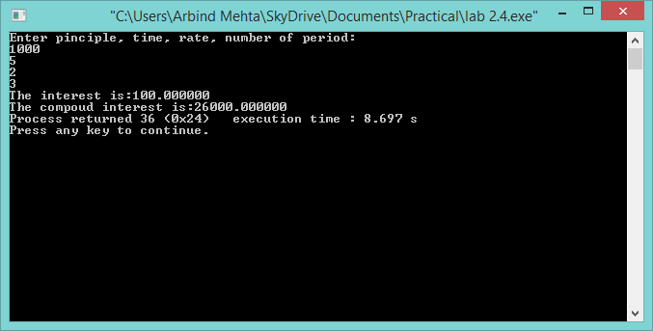

**Discussion & Conclusion:**

In this lab of C programming, based on the focused objective(s) to learn different data types, operation and expression in C

**Title:**

Write a program to swap two variables values with and without using third variables

**Objective:**

* To be familiar with different data types, operation and expression in C

**Problem Analysis:**

Based on problem, it is required to define two variable and assingn some value to it. Then a third variable of same data type is define. Then the value of one variable is copied to other and hence swaping is done.

|  |  |  |
| --- | --- | --- |
| **Input variables** | **Processing variables/calculations** | **Necessary header files/functions/macros** |
| a1, a2(int type) | c(int type) | stdio.h  coino.h  printf() |

**Algorithm:**

1. Start
2. Define variables: a1, a2, c
3. Display the a1, a2.
4. c=a1;
5. a1=a2;
6. a2=c
7. Display the a1, a2.
8. Stop

**Algorithm(without using third variable):**

1. Start
2. Define variables: a1, a2,
3. Display the a1, a2.
4. a1=a1+a2;
5. a2=a1-a2;
6. a1=a1-a2;
7. Display the a1, a2.
8. Stop

**Flowchart:**

Start

Define variable: a1, a2, c;

Print: a1,a2

c=a1; a1=a2; a2=c;

Print: a1,a2

End

**Flowchart(without using third variable):**

Start

Define variable: a1, a2

Print: a1,a2

a1=a1+a2; a2=a1-a2; a1=a1-a2;

Print: a1,a2

End

**Code:**

#include<stdio.h>

#include<conio.h>

void main()

{

clrscr();

int a1=1,a2=2,c;

printf("a and b are:%d,%d\n",a1,a2);

c=a2;

a2=a1;

a1=c;

printf("a and b are:%d,%d",a1,a2);

getch();

}

**Output (Compilation, Debugging and Testing):**

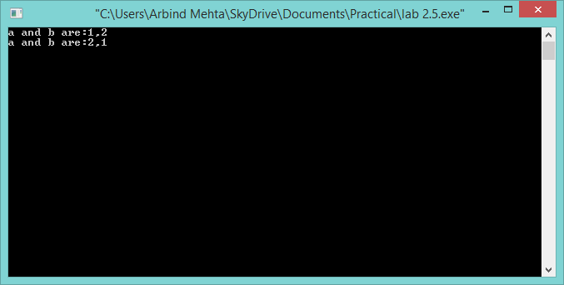

**Code(without using third variable):**

#include<stdio.h>

#include<conio.h>

void main()

{

clrscr();

int a=1,b=2;

printf("a and b are:%d,%d\n",a,b);

a=a+b;

b=(a-b);

a=(a-b);

printf("a and b are:%d,%d",a,b);

getch();

}

**Output (Compilation, Debugging and Testing):**

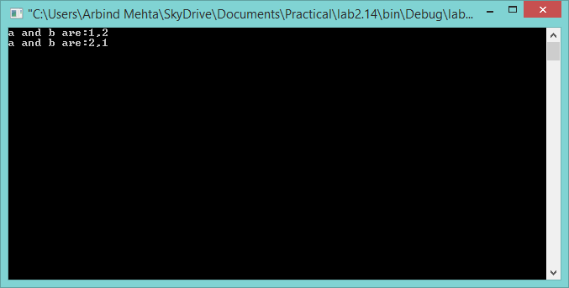

**Discussion & Conclusion:**

In this lab of C programming, based on the focused objective(s) to learn different data types, operation and expression in C

**Title:**

Write a program to check odd or even number (a) using modulus operator (b) using bitwise operator (c) without using bitwise and modulus operator (d) using conditional operator.

**Objective:**

* To be familiar with different data types, operation and expression in C

**Problem Analysis:**

Based on problem, it is required to get the input of integer number and check weather the given number is even or odd.

|  |  |  |
| --- | --- | --- |
| **Input variables** | **Processing variables/calculations** | **Necessary header files/functions/macros** |
| n(int type) | ans(int type) | stdio.h  coino.h  scanf()  printf() |

**Algorithm(using modulus operator):**

1. Start
2. Define variables: n
3. Take input from keyboard for all the input variables
4. If n is divisible by 2, display n is even number else display n is odd number
5. Stop

**Algorithm(using conditional operator):**

1. Start
2. Define variables: n, ans
3. Take input from keyboard for all the input variables
4. If n is divisible by 2, display n is even number else display n is odd number
5. Stop

**Algorithm(using bitwise operator):**

1. Start
2. Define variables: n
3. Take input from keyboard for all the input variables
4. If ((n&1)=1) print odd else print even
5. Stop

**Algorithm(without using modulus and bitwise operator):**

1. Start
2. Define variables: n
3. Take input from keyboard for all the input variables
4. If twice of half of given number is same number, print the number is even else print number is odd.
5. Stop

**Flowchart(using modulus operator/using conditional operator):**

Start

Define variable: n

Read n

End

(n%2)==0?

True False

Print “Number is odd”

Print “Number is even”

**Flowchart(using bitwise operator):**

Start

Define variable: n

Read n

(n&1)==1?

True False

Print “Number is even”

Print “Number is odd”

End

**Flowchart(without using modulus and bitwise operator):**

Start

Define variable: n

Read n

End

(n/2)*2==n?

True False

Print “Number is odd”

Print “Number is even”

**Code(using modulus operator):**

#include <stdio.h>

#include <conio.h>

int main()

{

clrscr();

int n;

printf("Enter the number to be checked:");

scanf("%d",&n);

if((n%2)==0) //using modulus operator.

printf("%d is even number.",n);

else

printf("%d is odd number.",n);

getch();

}

**Output (Compilation, Debugging and Testing):**

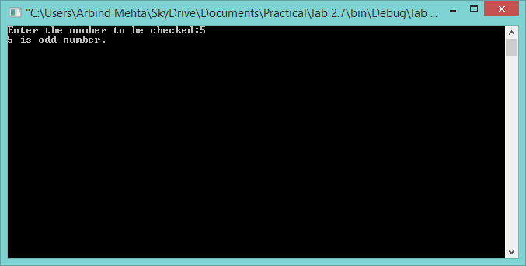

**Code(using conditional operator):**

#include <stdio.h>

#include <conio.h>

void main()

{

clrscr();

int n,ans;

printf("Enter the number to be checked:");

scanf("%d",&n);

ans=((n%2)==0) ? 1 : 0; //using conditional operator

if(ans==1)

printf("%d is even number.\n",n);

else

printf("%d is odd number.",n);

getch();

}

**Output (Compilation, Debugging and Testing):**

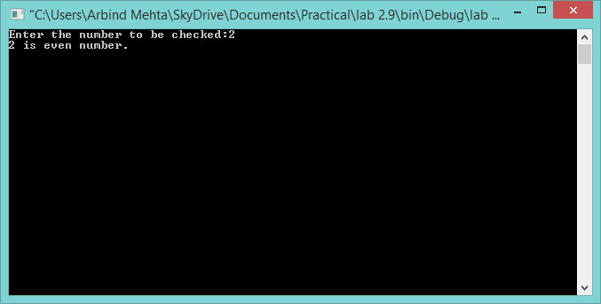

**Coding(using bitwise operator):**

#include <stdio.h>

#include <conio.h>

int main()

{

clrscr();

int n;

printf("Enter number to be checked:");

scanf("%d",&n);

if((n&1)==1)

printf("%d is odd number.",n);

else

printf("%d is even number.",n);

getch();

}

**Output (Compilation, Debugging and Testing):**

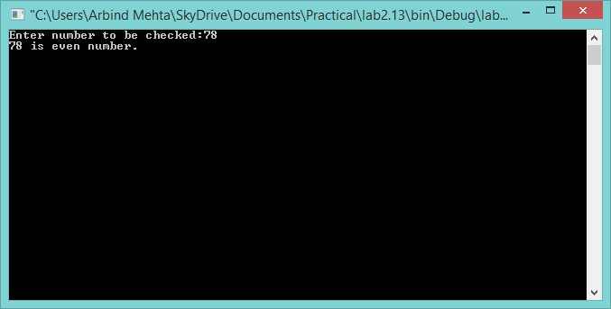

**Code(without using modulus and bitwise operator):**

#include <stdio.h>

#include <conio.h>

void main()

{ clrscr();

int n,ans;

printf("Enter the number to be checked:");

scanf("%d",&n);

if(((n/2)*2)==n)

printf("%d is even number.",n);

else

printf("%d is odd.",n);

getch();

}

**Output (Compilation, Debugging and Testing):**

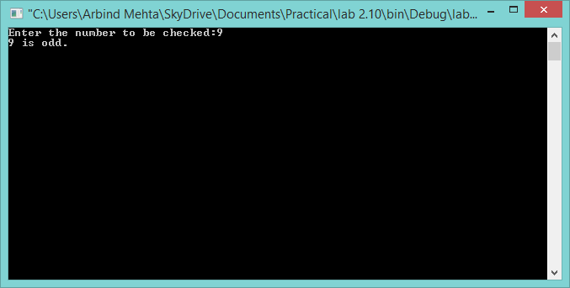

**Discussion & Conclusion:**

In this lab of C programming, based on the focused objective(s) to learn different data types, modulus, bitwise and conditional operator and expression in C

**Title:**

Print the value of y for given x=2 & z=4 and analyze the output. a. y = x++ + ++x; b. y= ++x + ++x; c. y= ++x + ++x + ++x; d. y = x>z; e. y= x>z? x:z; f. y = x&z; g. y= x>>2 + z<<1.

**Objective:**

* To be familiar with different data types, operation and expression in C

**Problem Analysis:**

Based on problem, it is required to define three integer variable and assign the value to them

|  |  |  |  |
| --- | --- | --- | --- |
| **Input variables** | **Processing variables/calculations** | **Output variables** | **Necessary header files/functions/macros** |
| x, z(int type) | y(int type) | y(int type) | stdio.h  coino.h  printf() |

**Algorithm:**

1. Start
2. Define variables: x=2, y, z=4.
3. a. y = x++ + ++x; b. y= ++x + ++x; c. y= ++x + ++x + ++x; d. y = x>z; e. y= x>z? x:z;
   1. f. y = x&z; g. y= x>>2 + z<<1.
4. Display the y
5. Stop

**Flowchart:**

Start

Define variable: x=2, y, z=4

a. y = x++ + ++x; b. y= ++x + ++x; c. y= ++x + ++x + ++x; d. y = x>z; e. y= x>z? x:z;

* 1. f. y = x&z; g. y= x>>2 + z<<1.

End

Print: y

End

**Code:**

#include <stdio.h>

#include <conio.h>

int main()

{

clrscr();

int x=2,y,z=4;

y=(x++)+(++x);

printf("y=%d\n",y);

y=(++x)+(++x);

printf("y=%d\n",y);

y=(++x)+(++x)+(++x);

printf("y=%d\n",y);

y=x>z;

printf("y=%d\n",y);

y=x>z?x:z;

printf("y=%d\n",y);

y=x&z;

printf("y=%d\n",y);

y=x>>2+z<<1;

printf("y=%d\n",y);

getch();

}

**Output (Compilation, Debugging and Testing):**

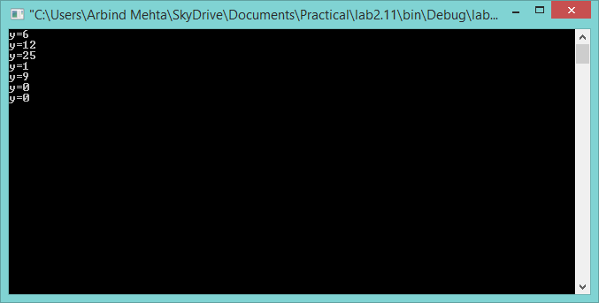

**Discussion & Conclusion:**

In this lab of C programming, based on the focused objective(s) to learn different data types, operation and expression in C

**Title:**

Write a program to print the size of char, float, double and long double data types in C

**Objective:**

* To be familiar with sizeof() function in C

**Problem Analysis:**

Based on problem, it is required to declare five variable of type integer, character, float, double, long double. Then by using sizeof() function return the size of variable which is been passed as argument this function.

|  |  |
| --- | --- |
| **Input variables** | **Necessary header files/functions/macros** |
| n1(int type),d1(double type), c1(char type), f1(float type), ld1(long double type) | stdio.h  coino.h  printf() |

**Algorithm:**

1. Start
2. Define variables:n, n1=5, c1=5, ld1=5, f1=5, c1=’a’
3. Display sizeof();
4. Stop

**Flowchart:**

Start

Define variable: n, n1=5, c1=5, ld1=5, f1=5, c1=’a’

Print:sizeof();

End

**Code:**

#include <stdio.h>

#include <stdlib.h>

int main()

{

clrscr();

int n1=5;

float f1=5;

double d1=5;

long double ld1=5;

char c1='a';

printf("size of integer is:%d\n",sizeof(n1));

printf("size of float is:%d\n",sizeof(f1));

printf("size of double is:%d\n",sizeof(d1));

printf("size of long double is:%d\n",sizeof(ld1));

printf("size of character is:%d\n",sizeof(c1));

getch();

}

**Output (Compilation, Debugging and Testing):**

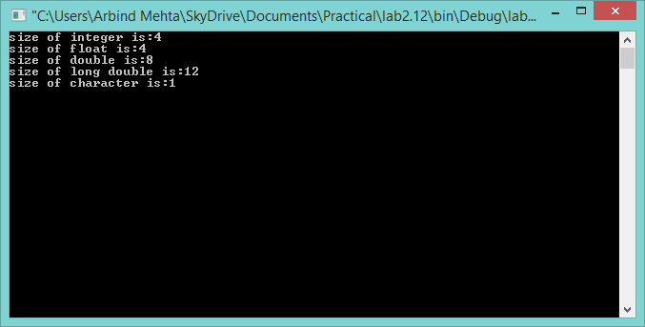

**Discussion & Conclusion:**

In this lab of C programming, based on the focused objective to be familier with sizeof() function, its syntax, argument and its uses.